**134 Harley Street, London W1G 7JY**

08

**Fall**



In Vitro Fertilisation (IVF)

A patient’s guide

It has now been over 35 years since the birth of the world’s first “test tube baby”: Louise Brown was born in 1978. Since then, an estimated total of over 8 million babies have been born worldwide as a result of IVF and there have been dramatic improvements in the technique.

# The stages of IVF treatment

Briefly, IVF involves stimulation of the ovaries to produce multiple follicles containing eggs. Those eggs are then retrieved and fertilised using a prepared sperm sample in order to create embryos. The embryos are cultured in the laboratory for a few days. A few cells are removed (biopsy) from the good quality embryos, if genetic testing (PGT) is being performed. The embryos are then frozen. Subsequently, a frozen embryo transfer is performed. The process can be divided into the following phases:

## Phase 1 – preparation

Like anything important in life, good preparation is vital to the success of fertility treatment. At Harley Street Fertility Clinic, we perform a thorough assessment prior to beginning an IVF treatment cycle and depending on the results, advise patients on pre-treatment preparation as indicated.

## Phase 2 – ovarian stimulation

Ovarian stimulation involves a course of daily injections of a stimulating hormone over a period of approximately ten days. During this period your ovarian response will be closely monitored using ultrasound scans and blood tests.

## Phase 3 – egg collection & sperm sample

The egg collection is a minor procedure typically lasting less than 30 minutes. The procedure is performed under mild sedation. On the same morning the male partner produces a semen sample (alternatively frozen or donor sperm can be prepared).

## Phase 4 – fertilisation & embryo culture

In conventional IVF, as opposed to ICSI, the prepared eggs and sperm are placed together in a culture dish to allow fertilisation to occur. The development of the embryos is monitored continuously by time-lapse microscopy (Embryoscope™), for the next 5 or 6 days. The embryos are assessed by an embryologist and an AI model (CHLOE) to determine which ones are suitable for further use.

## Phase 5 – embryo biopsy & freezing

After 5 or 6 days, good quality blastocyst stage embryos will be biopsied, if you are undergoing PGT, before being frozen by vitrification.

## Phase 5* (alternative) – fresh embryo transfer

In certain, rare, cases, your consultant may advise you to undertake a fresh embryo transfer. In such case, you will commence luteal support, progesterone, from the day of egg collection. Embryo transfer will be 5 or 6 days after egg collection.

## Phase 6 – frozen embryo transfer

You will be prepared for a frozen embryo transfer cycle in a natural or medicated cycle. When the lining of your uterus is ready, the embryo transfer will be arranged. Typically, one embryo is transferred to achieve a pregnancy.

## Phase 7 – early pregnancy

A pregnancy (blood) test will be arranged 9 days after embryo transfer. If positive, a pregnancy scan will be arranged 3 weeks later. If the scan is positive, we will advise you to have non-invasive prenatal testing at 10 weeks. We will typically monitor you until at least 12 weeks, at which time we will discharge you to your obstetrician or GP.

A visual summary of your IVF journey is shown below:

## Creating embryos:

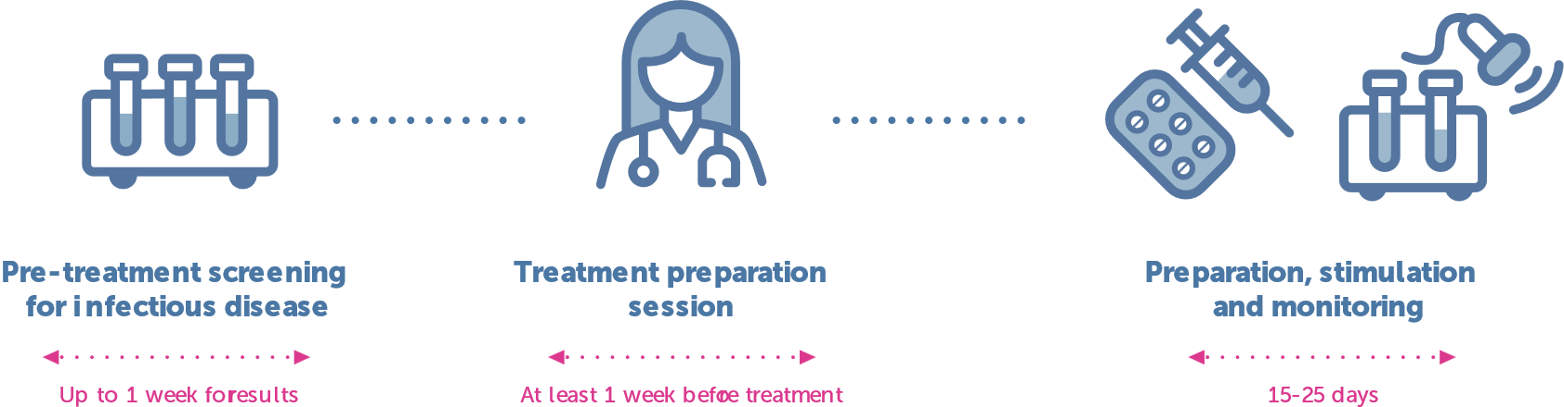

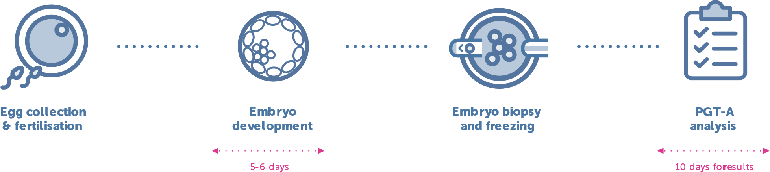

## Embryo transfer:

## 

Before considering any form of treatment, your doctor will perform a thorough assessment of your fertility. This will include ultrasound scans and hormone blood tests for you, as well as a semen analysis and possible further testing for the man. Without accurate information, a doctor cannot suggest the best treatment, nor can they optimise that treatment for your unique situation. Once a treatment plan has been devised, your doctor will advise you on preparing your body for the treatment. This may include further assessment and treatment of your immunological response, your nutrition and your lifestyle. We want you to be in optimum health when trying for a baby.

# Phase 1 – preparation

*“Fortune favours the prepared mind,”*

Louis Pasteur (1854)

[Salve on the App Store (apple.com)](https://apps.apple.com/gb/app/salve/id1282638920)

IVF requires a precise course of hormone treatment and patients are required to self-administer their medications. Before commencing treatment, all patients are required to be screened for common infectious diseases. This can be done at the Clinic or through your GP. Please speak with your patient coordinator if you would like a detailed list of the screening tests required. Fertility treatment is also tightly regulated and a patient’s consent to their treatment must be in writing. Hence, all patients must complete consent forms prior to starting treatment.

We therefore require patients and their partners to arrange a treatment preparation appointment with our nursing team prior to starting treatment in order to review their treatment plan, screening tests, consent forms and answer any queries before starting. The treatment timeline, including the scheduled dates for monitoring (scans and blood tests) and expected egg collection date will be confirmed at this appointment. Thus, the nursing team will provide you with the relevant appointments needed during ovarian stimulation.

We use our patient app, called Salve, to communicate with you during your treatment. Please download Salve on your smartphone from the Apple App Store or Google Play.

[](https://apps.apple.com/gb/app/salve/id1282638920)

[](https://play.google.com/store/apps/details?id=co.salvehealth.salve)

[Salve - Apps on Google Play](https://play.google.com/store/apps/details?id=co.salvehealth.salve)

Or scan the QR code below:



**The Clinic code is “184775”.**

### Preparation checklist:

* Arrange treatment preparation appointment with nursing team to review consent forms, check validity of screening test results and schedule treatment appointments
* Arrange medications for treatment (if you are not purchasing from the clinic)
* Download Salve
* Abstain from intercourse or use barrier contraceptives during treatment cycle and preceding cycle
* Inform the clinic immediately if you suspect you have become pregnant

The main protocol used for ovarian stimulation at Harley Street Fertility Clinic is called the “Short antognist” protocol.

# Phase 2 – ovarian stimulation

*“you can, you should, and if you’re brave enough to start, you will,”*

Stephen King (2000)

Typically, you will be primed ahead of ovarian stimulation in the last 7-10 days of your preceding cycle using tablets of oestrogen (Progynova) or norethisterone. This will help prepare your ovaries for stimulation and synchronise the development of antral follicles.

You will commence ovarian stimulation shortly after your period arrives. Stimulation medications, which make the follicles in your ovaries grow, are referred to as gonadotrophins. Your consultant may decide to use a single gonadotrophin or a combination of two. They are to be self-administered daily and come in the form of injections. Gonadotrophins contain follicle stimulating hormone (FSH), the brand names are Gonal-F, Rekovelle, Bemfola and Fostimon, or human menopausal gonadotrophin (hMG), the brand names are Menopur or Meriofert.

These injections will typically need to be administered daily for 10 to 12 days. We advise you to administer the injections at the same time every evening.

You will be given an initial daily dose based upon your first scan and blood tests. The response of your ovaries will then be monitored closely using ultrasound scans, in which the size and number of your follicles is measured, and blood tests to measure your hormone levels. The initial dose may be adjusted after each scan and blood test in order to optimise the response of your ovaries and yield the maximum number of eggs.

Once your follicles start to grow, typically after 5 days of stimulation, you will start another injection to inhibit ovulation. This injection is called an GnRH antagonist, the brand name is Fyremadel.

When your follicles have grown to a suitable size and your hormones are at the appropriate levels, you will be asked to self-administer a ‘trigger injection’ to stimulate final maturation of your eggs. Your consultant may opt to use a single trigger or a combination of two triggers (‘double trigger’), the brand names are Gonasi, Buserelin and Ovitrelle. The timing of these injections is critical (it is usually precisely 36 hours before the egg collection) and your nurse will advise you about when to administer it. If the eggs are collected too soon, they will not be mature and are unlikely to fertilise; conversely, if the egg collection is performed too late then you may have already ovulated and released your eggs, i.e. the doctor will not be able to collect them.

It is important that you monitor how much medications you currently have and speak to your nurse if you need additional medications. Please ensure that you have enough medications until your next appointment.

In certain cases, your consultant may choose to use a different ovarian stimulation protocol called the “Long Luteal protocol.” This involves suppression of your natural cycle (“down-regulation”) beginning on day 21 of your preceding cycle, typically using a daily injection of a GnRH analogue, the brand name is Buserelin.

Down-regulation is confirmed by an ultrasound scan and blood test after two weeks. Once effective down-regulation is confirmed, you will be asked to commence ovarian stimulation with monitoring as above. However, in this protocol, since you are down regulated there is no need for the GnRH antagonist.

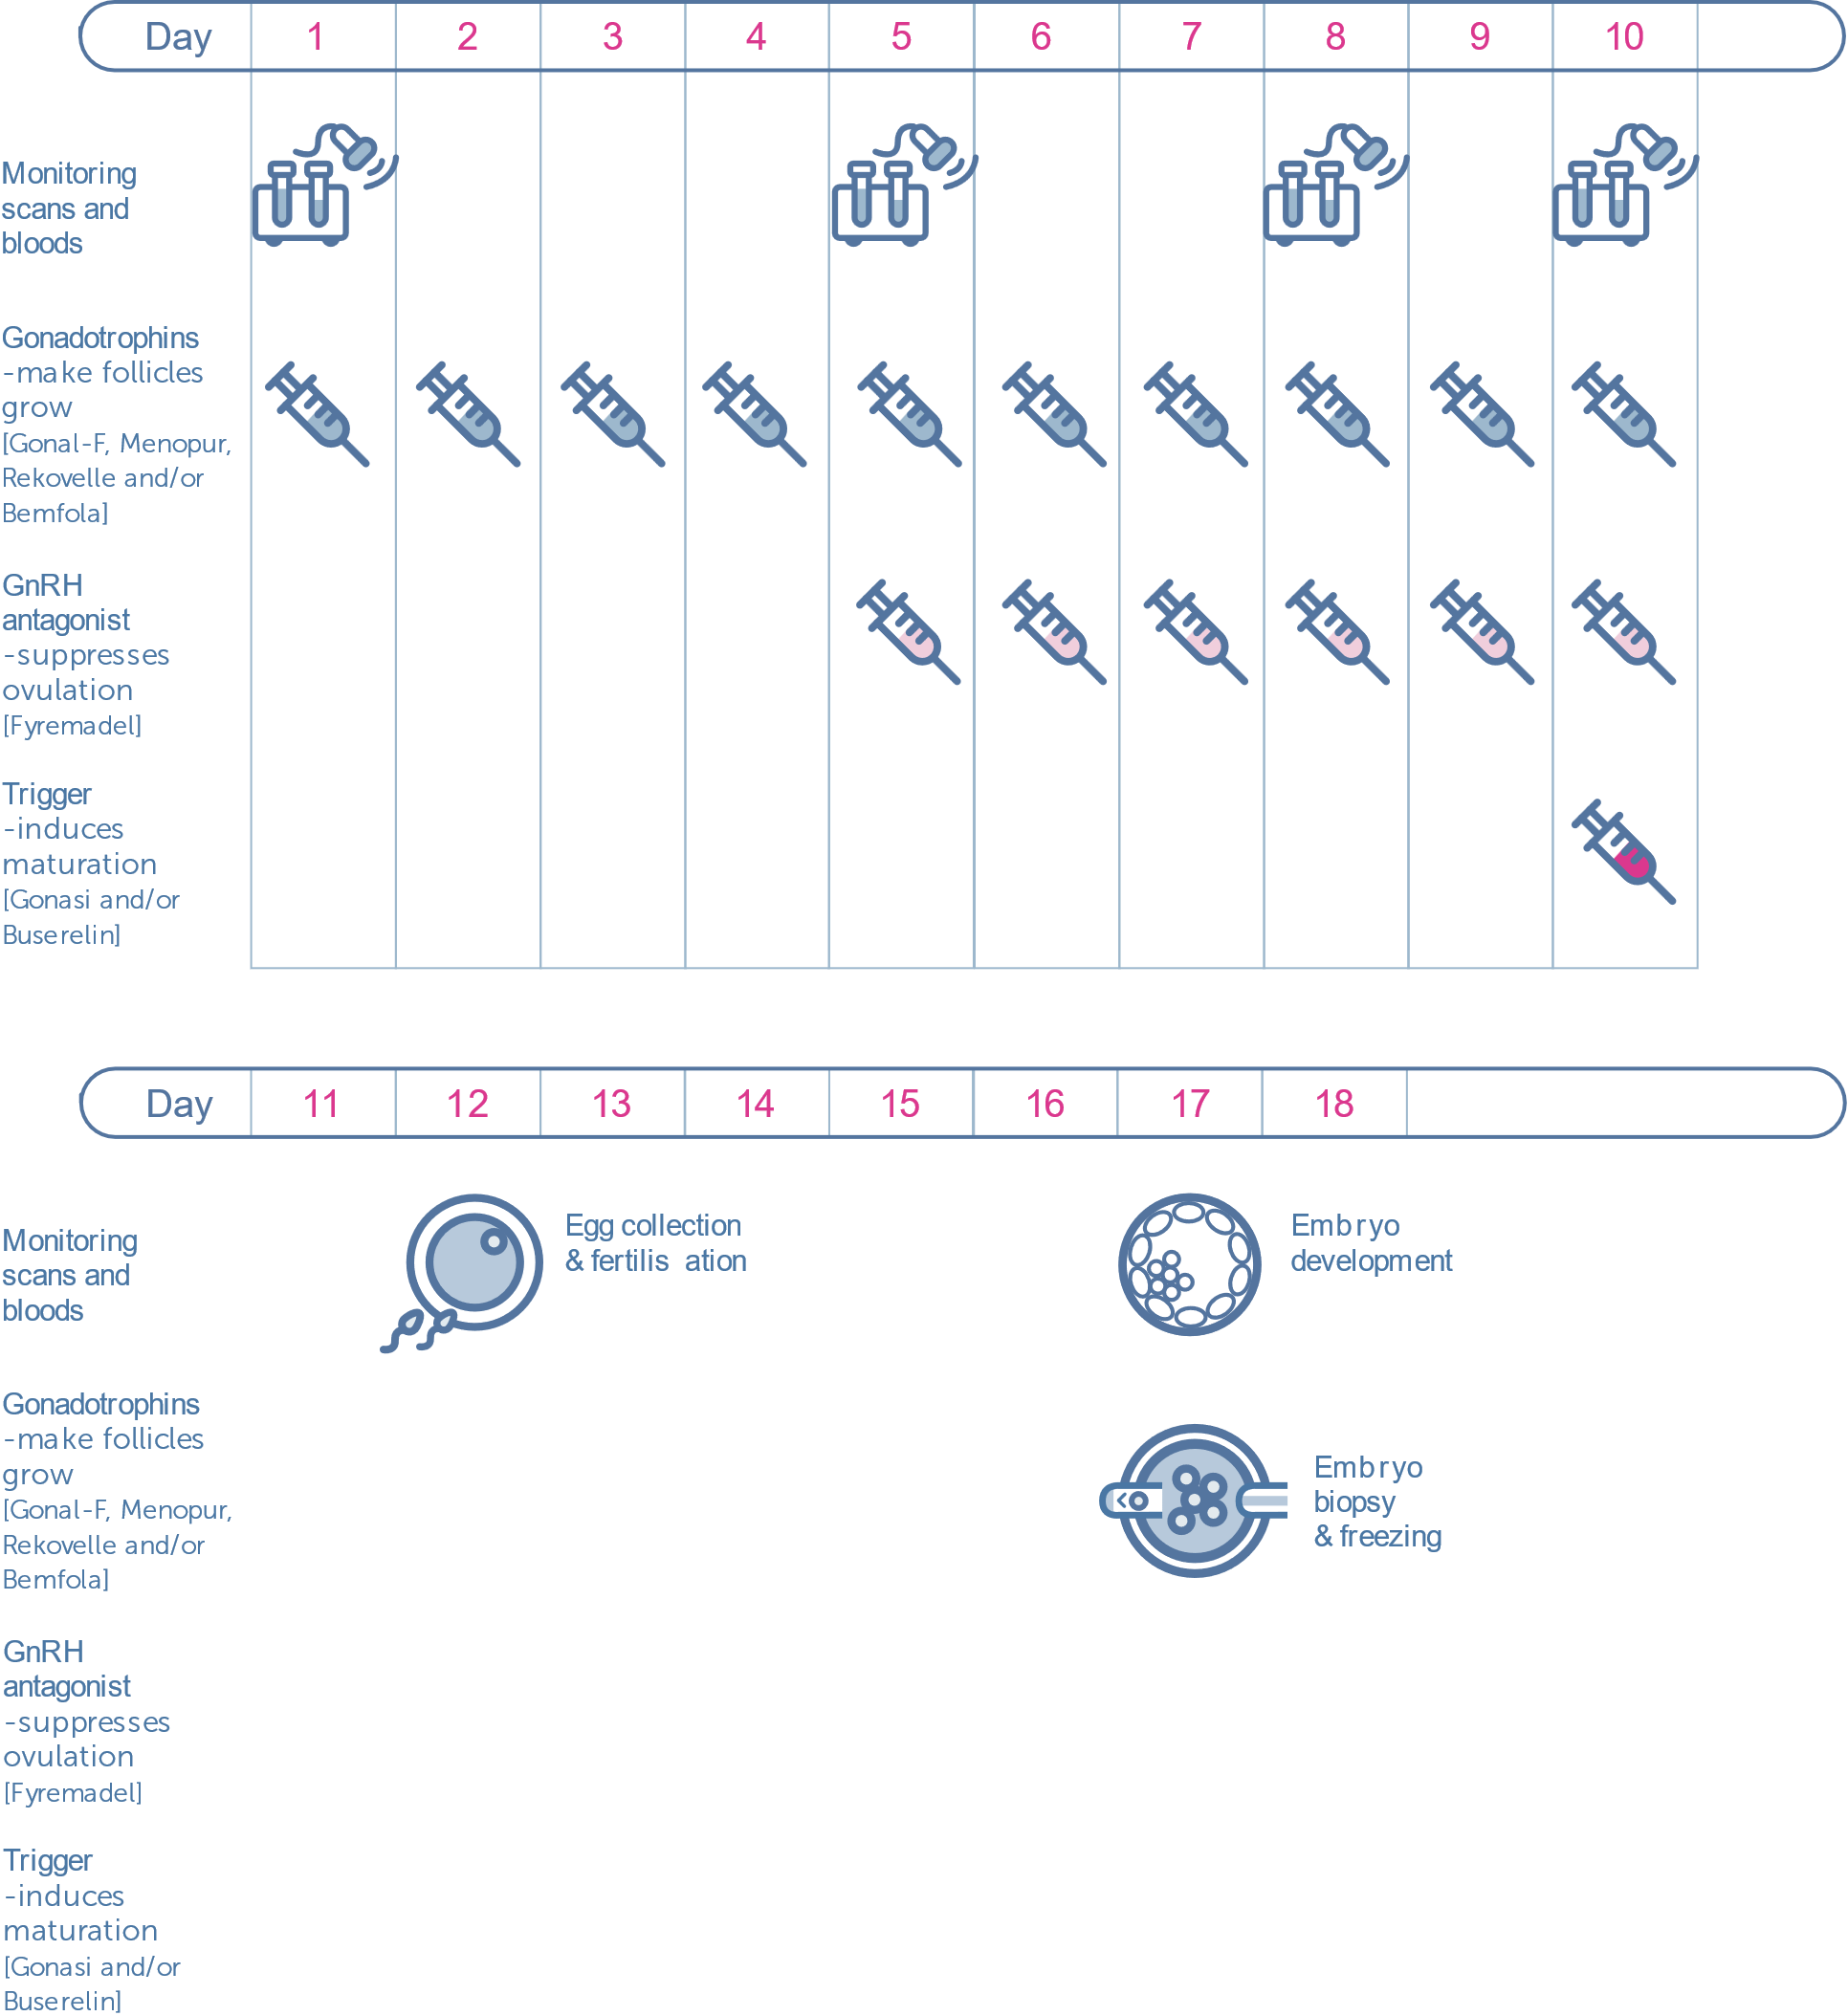Here is a visual timeline for the Short protocol:

## Possible complications of stimulation

### Poor response

Sometimes, follicles fail to respond well to the stimulating injections. Unfortunately, in these situations, there is no remedy and you may be advised to abandon the cycle. Your doctor will discuss this with you at the time and further management can be discussed at a follow-up consultation with your doctor. Typically, we would advise patients who have presented with poor ovarian response to start with a higher dose of stimulation, try different medications or try a different treatment protocol.

### Stimulation checklist:

* Arrange medications for treatment (if you are not purchasing from the clinic)
* Check Salve works
* Abstain from intercourse or use barrier contraceptives during treatment cycle
* Attend monitoring scan appointments and continue medications as advised
* Ensure you have enough medications until next appointment

### Ovarian hyperstimulation syndrome (OHSS)

OHSS is possibly the most important complication of IVF treatment: the response of your ovaries to stimulation may be excessive and result in the ovaries becoming enlarged and fluid accumulating in the abdominal cavity. OHSS can occur when there are an excessive number of follicles (>20) or very high levels of the hormone oestradiol. OHSS can be characterised by varying degrees of severity:

* **Mild** OHSS can present with symptoms of abdominal swelling and discomfort, nausea, vomiting and diarrhoea. Ultrasound scans will show ovarian enlargement of less than 5 cm. Mild OHSS is monitored using ultrasound scans and can be treated with increased oral fluids and mild painkillers, such as Paracetemol.
* **Moderate** OHSS can present with symptoms similar to mild OHSS with increased severity. Ultrasound scans will show ovarian enlargement between 5 and 12 cm, and fluid accumulation in the abdominal cavity. Moderate OHSS is closely monitored using ultrasound scans and blood tests. Treatment is as per mild OHSS plus administration of intravenous fluids if necessary.
* **Severe** OHSS can present with symptoms similar to moderate OHSS as well as difficulty in breathing. Ultrasound scans will show ovarian enlargement of more than 12 cm. Luckily, severe OHSS is rare an only occurs in less than 0.5% of patients. Severe OHSS may require hospital admission. Drainage of fluid in the abdomen will relieve some of the symptoms and quickly help patients recover.

## Egg collection

# Phase 3 – egg collection and sperm sample

*“Always laugh when you can, it is cheap medicine”*

Lord G. Byron

The egg collection procedure is routinely performed as a day-case operation under mild intra-venous sedation (also referred to as conscious sedation) to minimise any pain or discomfort. You should not eat or drink from midnight the night before, unless instructed otherwise. You may shower or bathe on the morning of your procedure. You must not wear any make-up, perfume, nail varnish, jewellery or contact lenses on the day. Your partner or a friend should be present on the day to escort you home.

A nurse will admit you into your bay in our recovery ward. She will confirm your name and date of birth, and that you have not had anything to eat or drink since the night before. The nurse will also check if you have any allergies or other conditions. She will then provide you with materials to change into for the procedure. When you are ready, you will be introduced to the consultant anaesthetist who will talk to you about the sedation used for the egg collection.

Figure 1 vaginal egg collection

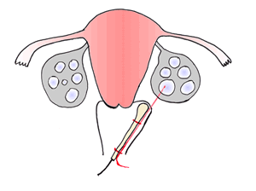

Subsequently, you will be admitted into theatre, where you will be introduced to the embryologist. The embryologist will ask you to state your name and date of birth as part of our witnessing procedure. They will check this against your records and confirm the culture dishes that will be used for you in the lab are correctly labelled.

A small canula is placed in a vein in your arm or hand for administering the anaesthetic medications during the procedure. The anaesthetist will constantly monitor your vital signs during the procedure to ensure you are appropriately sedated and kept relaxed with minimal pain.

The eggs are collected using a fine needle inserted through the vagina under ultrasound guidance, as shown in Figure 1. In certain cases, if one or both ovaries are not accessible vaginally, the egg collection may be performed abdominally. The fluid from each follicle is aspirated and the fluid is passed to the embryologist who examines the it to identify an egg. If there is no egg in the fluid, the follicle is flushed with media and aspirated again. Once the follicles in one ovary have been aspirated the doctor will aspirate the follicles in the other ovary. Not all follicles will contain eggs and so the number of eggs retrieved may not correspond to the number of follicles aspirated.

The egg collection procedure typically takes less than 30 minutes. Since you will have received sedation, you will be monitored for two hours after the procedure before being discharged.

**You will need to be escorted home by your partner or friend.**

**You should not drive, operate heavy machinery or sign any important documents that day. We would advise you to take full rest for the day.**

Some women will feel discomfort or soreness in the abdomen after the egg collection. Mild pain killers such as Paracetemol can be used to control this symptom and they will not interfere with your treatment. There may also be some minimal spotting, which will typically be dark brown in colour. This can be caused by the ozzing from the needle puncture site in the vagina. Some women also feel nauseous and vomit due to the anaesthetic but this should wear off quickly. If any symptoms become severe or persist please contact the clinic immediately.

If you are having a fresh embryo transfer, you will be asked to start luteal support, progesterone, from the day of your egg collection to help the lining of the uterus (the endometrium) thicken and be receptive to an embryo. Typically, progesterone support is administered twice daily (each morning and night) as a pessary to be inserted into the rectum or as a daily intra-muscular injection. Progesterone support should be continued until your pregnancy test. In the pleasant event of the test being positive, progesterone support is to be continued for another two months – until 12 weeks of pregnancy. Around the time of your embryo transfer we will perform a blood test to check your progesterone level. If it is low we will advise you to take additional medications to increase the level as required.

### Egg collection checklist:

* Do not eat or drink from midnight the night before
* Do not wear any make-up, perfume, nail varnish, jewellery or contact lenses
* Bring your partner or a friend with you
* Arrange for your partner or friend to escort you home
* Follow all instructions provided by the doctor and nurse after the procedure
* Begin progesterone support that evening

## Sperm sample

When your treatment is planned by your consultant, you will discuss whether you will use a fresh sperm sample or a frozen one.

If the male partner’s sperm is being used in your IVF treatment, he will need to produce a fresh sample at the clinic at the time of your egg collection. He should abstain for at least three days and no more than five days before the egg collection for an optimal sample.

The sperm sample is generally produced by masturbation. It is recommended that the man washes his hands and genitals with soap, rinses with clean water and dries with a clean towel. No lubricant should be used when producing the sample in order to avoid toxicity to the sperm. The sample is collected into a sterile plastic container that is not toxic to sperm. If the man knows that he will find it difficult to produce a sample at the clinic they can request to produce the sample at home and bring it to the clinic. If the man finds it difficult to produce into the specimen jar, they can use a special condom provided by the clinic. Please discuss these matters with a nurse or member of the laboratory staff.

If the sample is not of sufficient quality, the embryologist may ask him to produce another sample. If this is not successful, the embryologist and doctor may recommend that your eggs are fertilised by ICSI rather than conventional IVF.

If you are using a frozen sperm sample, the laboratory will thaw and prepare the sample as required. If the male partner is undergoing surgical sperm retrieval on the day of egg collection, he will be provided with instructions for the procedure.

## Day 0 – fertilisation

# Phase 4 – fertilisation and embryo culture

*“Hope is a waking dream”*

Aristotle

After the eggs have been collected, they are temporarily kept in culture media in an assigned culture dish in an incubator. The male partner’s sperm sample, or donor sperm sample, is then prepared by washing and separating the normal moving sperm from the seminal fluid and abnormal or non-moving sperm. In a conventional IVF cycle, the prepared sperm and eggs are placed together in culture media in an assigned culture dish. In an ICSI cycle, the eggs are denuded and a single sperm is micro-injected into each mature egg. The dish is placed in an incubator overnight to allow fertilisation to take place.

## Day 1 – fertilisation is observed

The next morning, one of our embryologists will check each egg under a microscope to see if fertilisation has taken place. Fertilised eggs are called embryos. At this stage in their development the embryo is still only one cell and the same size as the egg. Successful fertilisation is indicated by the presence of two pro-nuclei within the embryo: one pro-nuclei contains genetic material (DNA) from the egg (female) and the other contains DNA from the sperm (male), as shown in Figure 2a. The embryologist will call you to inform you about the fertilisation results. On average, 60 - 70% of the eggs collected fertilise normally. On rare occasions, none of the eggs are fertilised by the sperm and no embryos develop. This is result is extremely disappointing and we will arrange an appointment as soon as possible with your consultant to discuss your options. Your consultant will also offer you the opportunity to see one of our counsellors or nurses for a session of supportive counselling.

Figure 2 Embryo development: a) Day 1 embryo with 2 pro-nuclei, b) Day 2 embryo with 4 cells (grade 4), c) Day 3 embryo with 8 cells (grade 4) and d) Blastocyst (grade 3AA)

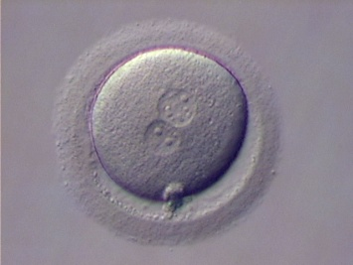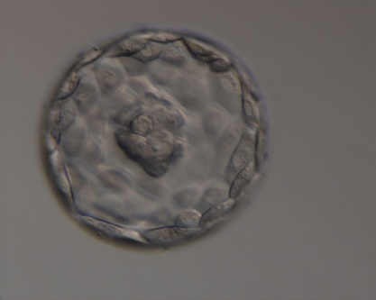

Pro-nuclei

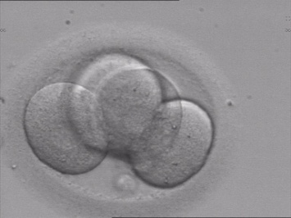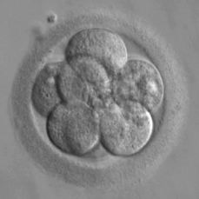

**a**

**b**

**c**

**d**

Foetal cells

(inner cell mass)

Placental cells

(trophectoderm)

## Days 2 and 3 – embryos are evaluated by the number and quality of cells

On days 2 and 3, one of our embryologists will assess the embryos for further cell division. The embryologist will grade each embryo based on the number and quality of cells. We expect normal embryos to develop as follows:

* Day 2 embryos should contain 2-5 cells
* Day 3 embryos should contain 6-8 cells

On days 2 and 3, our embryologists will grade each embryo based on the level of fragmentation within the embryo. A grade 4 embryo (the best) will have the least fragmentation. A grade 1 embryo (the poorest) has the highest degree of fragmentation.

Please note that poor quality embryos can also result in a live birth, but they have a lower probability of success than a higher quality embryo. There is **no** correlation between the quality of the embryo and birth defects.

One of our embryologists will call you on day 3 to explain the development of your embryos.

Embryos are not observed on day 4.

## Days 5 and 6 – blastocyst development

The blastocyst stage is the last stage of embryo development before the embryo hatches and implants into the lining of the uterus. A blastocyst is characterised by a fluid filled cavity called a blastocoele. At the blastocyst stage cells develop into two types: the inner cell mass that becomes the foetus and trophectoderm cells that develop into the placenta. These are indicated in Figure 2d above.

On average 40-50% of good quality day 3 embryos are expected to reach the blastocyst stage by days 5 or 6. Blastocysts are graded using a different system than day 2/3 embryos: the grade will consist of a number followed by two letters. The number indicates how developed the blastocyst is: with 1 being an early stage blastocyst and 5 being a completely hatched blastocyst. The first letter denotes the quality of the foetal cells: A being the best and E being the poorest quality. The second letter denotes the quality of the placental cells: again A being the best and E being the poorest quality. E.g. a blastocyst graded 3AA indicates an expanded blastocysts with excellent quality foetal cells and excellent quality placental cells.

## Time-lapse microscopy (Embryoscope™)

Conventionally embryologists will assess embryos once a day during their development by taking them out of the incubator and examining them under a microscope. The new technique of time-lapse microscopy uses a special incubator (Embryoscope™) that contains a camera and microscope within it. The Embryoscope takes an image of the embryos every 15 minutes and generates a time-lapse movie of the embryos as they develop, without ever removing them from the incubator. Time-lapse videos of embryos enable the embryologist to optimise embryo selection by studying their timelines of division and comparing them against the ideals. This new technique has been shown to improve pregnancy rates because patterns of embryo development can be monitored to select the best embryos.

## CHLOE EQ – AI based embryo assessment

Traditionally, embryos have been assessed by embryologists looking at embryo shape (morphology) and their development in time (morphokinetics). However, the grading of embryo quality is still subjective and there can be variation between embryologists. To help reduce the subjectivity and variability of embryo assessment, we have introduced CHLOE EQ from Fairtility. CHLOE EQ is an AI powered tool that automatically captures the key development points of an embryo (annotation of embryo images). CHLOE EQ then scores an embryo by interpreting subtle visual and developmental attributes that contribute to the understanding of the embryo’s potential for implantation.

## Embryo biopsy for genetic testing (PGT-A)

# Phase 5 – embryo biopsy and freezing

*“If I have the belief that I can do it, I shall surely acquire the capacity to do it even if I may not have it at the beginning.”*

Mohandas K. Gandhi

It is well established that one of the main reasons causing miscarriage of the failure of embryos to implant is genetic (or chromosomal) abnormality. Furthermore, the risk of genetic abnormalities being present increases with maternal age.

DNA is a molecule that contains information (in the form of genes) on how each cell in the body should grow and function. DNA is wrapped up into structures called chromosomes that are present in every cell in the body.

Humans usually have 23 pairs of chromosomes (22 autosomes plus 1 pair of sex chromosomes) in each cell of their body. Having extra or missing chromosomes (aneuploidy) can result in failure of an embryo to implant, miscarriage and conditions such as Down syndrome.

PGT-A (formerly called PGS) is a genetic test performed on embryos, created by IVF, to identify whether an embryo has the correct number of chromosomes (euploidy).

The data below compares live birth rates with and without PGT-A. As you can see the birth rate is significantly better with PGT-A, in particular for older patients.

Further, performing PGT-A significantly reduces the risk of miscarriage for all patients.

For this reason, we recommend all patients undergo PGT-A as a part of their IVF cycle to maximise their chances and minimising your time to achieving a healthy pregnancy.

PGT-A is performed by removing a small sample of cells (biopsy), once the embryo is blastocyst, from the outer layer - known as the trophectoderm (this later develops into the placenta). The embryos are then frozen, while the biopsies are sent for genetic analysis. This typically takes 2 weeks. Please refer to our leaflet on PGT-A if you would like further information.

Figure 3 Live birth rates with and without PGT-A (source: SART 2016)

## Embryo freezing

After they have been biopsied, the embryos will be frozen. All embryo freezing in our laboratory is performed by vitrification, a technique by which embryos are rapidly frozen into a glass like state (hence “vitrified”). This process avoids the formation of ice crystals that damage the cellular structure within embryos. We expect more than 98% of good quality embryos to survive the freezing and thawing process when using vitrification.

Frozen embryo transfer has now been used for many years and has resulted in successful delivery of several thousand healthy babies. There is no data to indicate any increased risk of abnormalities due to the freezing and thawing process. In fact, studies have shown that there is less risk of bleeding during pregnancy, lower chance of a baby being born underweight, less risk of a baby being born premature and less risk of death when frozen embryos compared to using fresh embryos. (Maheshwari et al., review, Aberdeen University, 2012) In fact, our belief is that one should freeze all embryos in an IVF or ICSI cycle and transfer them at a later date.

## Embryo storage

Embryos can safely remain in storage almost indefinitely and without degradation in their quality or viability. Your embryos can be legally stored for up to 55 years. However, you must renew your consent to storage every 10 years.

You will be charged independently of your treatment cycle. In the first year your embryos are frozen you will be charged on a pro-rata basis until December of that year. Then each subsequent December, we will contact you about continuing to store your embryos for the upcoming year.

## Planning for the transfer

# Frozen embryo transfer (FET)

*“The best way to predict the future is to create it.”*

Abraham Lincoln

A consultation with your doctor will be arranged for you a few weeks after egg collection. If you undertook PGT-A, your consultant will discuss the results of the testing. They will also discuss the quality of the embryos that were frozen and choose which one to transfer. Your consultant will then plan out the frozen embryo transfer cycle.

As before, you will be provided with consent forms to complete for the frozen embryo transfer and need to ensure your infectious screening tests are still valid. A treatment preparation consultation will be arranged for you as before. The treatment timeline, including the scheduled dates for monitoring (scans and blood tests) and expected embryo transfer date will be confirmed at this appointment.

Frozen embryo transfer can be performed as part of during a natural cycle, without any medications, or in a hormone controlled cycle, in which medications are used to control the hormones. Your consultant will advise you as to which option is suitable for you based on your medical history and age.

The embryo transfer will be performed under ultrasound guidance and there is no requirement for anaesthesia.

## Natural cycle FET

It is important that frozen embryos are transferred at the correct time in a natural cycle. You will be closely monitored using ultrasound scans and advised to use Luteinising Hormone (LH) urine test kits in order confirm a normal ovulatory cycle. Once ovulation has occurred, the frozen embryos will be thawed and transferred into your uterus on the appropriate day. Alternatively, ovulation may be induced using medications, this is called a modified natural cycle.

## Medication controlled FET

If you are having an FET as part of a medication controlled cycle, you will start medications to suppress or down regulate your natural hormones typically from day 21 (of a regular 28 day cycle). An ultrasound scan and blood test will be arranged approximately two weeks later to check if the hormonal suppression has been effective. If the scan is good then you will start medications (Oestradiol valerate tablets) to prepare the lining of your womb (the endometrium). The development of the endometrium will be monitored using ultrasound scans and blood tests (typically two visits). If the endometrium is not thick enough, you may also be asked to start Oesterogen patches. The embryo transfer will be arranged once the endometrium is thick enough. At this stage you will be asked to start Progesterone supplementation (typically in the form of injection) for luteal phase support. You will continue the oestrogen medications but will stop any down regulation medications.

## Laser assisted hatching

During the freezing process, the shell (or outer protective layer) of embryos can become hard. Laser assisted hatching involves making a hole in the outer layer of an embryo to help the hatching process and may help to improve the embryo implantation rate. Assisted hatching is performed immediately prior to the embryo transfer.

## Endometrial preparation

In order to increase the probability of implantation a process called an endometrial scratch and saline hysterogram is offer to our patients undergoing an FET cycle. Recent research suggests that gently ‘scratching’ the endometrium causes the uterus to start a ‘repair reaction’, which may increase the probability of embryo implantation. At the same time the uterine cavity is washed with saline to provide a clean surface for embryo implantation. This procedure is performed 7 to 10 days before your period begins (i.e. at the time of down regulation in a hormone controlled FET cycle).

## The embryo transfer procedure

The embryo transfer is a much simpler procedure than egg collection and is normally performed without any anaesthesia. Embryo transfer is performed under ultrasound guidance to ensure that the embryo(s) is placed in the optimal location within your uterus.

You will need to have a full bladder to allow visualisation of the uterus under ultrasound. A full bladder can also correct the angle between the cervix and the body of the uterus, thus making the embryo transfer easier.

Your consultant will first clean the cervix before gently passing a soft outer catheter through the vagina and cervix into the uterine cavity. Once the outer catheter is in the optimal location they will ask the embryologist to load the embryos. You will be shown the embryo(s) to be transferred, under a microscope, on a large screen in theatre before they are loaded into the soft inner catheter. The embryologist will hand the soft inner catheter to the consultant who will thread it inside the soft outer catheter. The embryos are then gently placed inside the uterine cavity.

The catheter is withdrawn and checked under the microscope to ensure the embryo(s) was transferred (again you will be able to see this on the screen in theatre). Occasionally, the embryo(s) remains in the catheter and the transfer will be repeated until successful. This does not affect the chance of pregnancy.

The question present on every patient’s mind at embryo transfer:

“Will the embryo fall out when I get up?”

Luckily, the answer is no. However, we advise you to lie down for 15 minutes after the procedure. While you may resume normal activities after the procedure, we advise against any high impact exercise, over exertion, swimming, jogging, riding or any heavy lifting until the pregnancy test. This does not mean bed rest and we encourage you to take leisurely walks or similar activities.

## Post embryo transfer

The luteal phase is the latter phase of a woman’s cycle during which pregnancy can occur. The hormone progesterone is significantly higher during the luteal phase than other phases of the cycle. The high levels of progesterone during the luteal phase have been shown to be required for successful pregnancy. (Practice Committee of ASRM, Fert. Stert., November 2008). Therefore as a part of all frozen embryo transfer cycles we will measure a your progesterone level around the time of embryo transfer. If the level is satisfactory, you will be asked to continue the luteal phase support medications you are on. If the level is low, you will be asked to start additional medications as required.

Nine days after embryo transfer we will ask you to come to the clinic for your pregnancy test. We understand that this period of waiting can be very stressful for couples: patients have said that it was the longest two weeks of their lives. Unfortunately, there is nothing one can do to alter the outcome, so we advise patients to stay positive, hydrated, eat well, sleep well and hope for the best. We are rooting for you too!

# Early pregnancy

*“Success is not final, failure is not fatal: it is the courage to continue that counts.”*

Winston S. Churchill

The pregnancy test is performed using a blood test for the level of -HCG (Human Chorionic Gonadotropin) and we will get the results back from our laboratory within 4 to 6 hours.

## Positive pregnancy test

Congratulations! A positive pregnancy test indicates that one or more embryos have implanted. We will arrange an early pregnancy scan 3 weeks after the test and you will be advised to continue your progesterone support until that scan.

## Negative pregnancy test

Sadly, this means that your treatment has not been successful. If the pregnancy test is negative, progesterone support should be stopped. Generally, you will have started bleeding before the test, if not your period will start in the next few days. We know that a negative result is extremely disappointing for patients and can be quite stressful. We can arrange for you to see a counsellor or one of our nurses for a session of supportive counselling. We advise you to arrange a follow up consultation with your doctor once you have had time to recover from the shock and you are ready to discuss plans for future treatment.

## Why do cycles fail?

The process of embryo development and implantation is very complex and determined by many factors. Unfortunately, many of those factors are poorly understood and hence it is often not possible to diagnose the specific cause of failure. However, each person is unique and it is often possible to learn from each treatment cycle. Your consultant will review the previous cycle with you and discuss any further investigations or treatments that should be performed prior to trying again.

## When can I try again?

We generally recommend that you wait for your cycle to return to normal before attempting treatment again. Your consultant will discuss your future treatment options with you during your follow up consultation. We usually recommend using any frozen embryos before attempting another fresh IVF cycle.

## Early pregnancy scan

If the pregnancy test is positive, we will arrange an early pregnancy (7 week) scan. This will be a transvaginal ultrasound scan and can detect:

* Number of pregnancies and their viability
* Crown rump length (CRL) of foetus and whether is it appropriate for this period of gestation
* Any gross abnormalities
* Location of pregnancy

At 7 weeks, the foetus is likely to be roughly 1 cm in length, i.e. extremely small. Therefore this scan will not able to determine the sex of the baby or any other physical features or abnormalities. If a viable pregnancy is confirmed, we will advise you about continuing your medications.

## Non-invasive prenatal testing (NIPT)

We advise all patients to undergo non-invasive prenatal testing for the most common genetic conditions that affect foetuses.

Harley Street Fertility Clinic offers the NeoTest from Juno Genetics. It is completely safe for the mother and her unborn child. The test can potentially examine all 24 chromosomes, to bring peace of mind to future parents.

The NeoTest can be performed from 10 weeks of gestation.

NeoTest offers a high detection rate for the specific chromosome abnormalities tested and a low false-positive rate. Importantly, the non-invasive nature of the test means that it does not increase the risk of miscarriage – unlike traditional invasive prenatal tests. The test provides accurate answers when they matter most — simply, safely, sooner.

## Two test options:

**Neo5**: Detects abnormalities in chromosomes 21, 18, 13 and the most common anomalies in the sex chromosomes (X and Y). Neo5 tests the baby’s risk of Down syndrome, Edwards’ syndrome or Patau’s syndrome. It also reveals the possible existence of abnormalities in the X and Y sex chromosomes.

**Neo24**: Detects abnormalities in all 24 chromosomes. Hence, this option detects all chromosomal abnormalities, including Down’s Syndrome, Edwards syndrome, Patau syndrome, Turner syndrome, Klinefelter syndrome, XYY syndrome and Trisomy X syndrome.

## How is it performed?

Your baby’s cell free DNA can be detected circulating in your blood and so it requires a simple blood test, which is sent to the lab, analysed and the results returned within one week. The test uses DNA sequencing to count the number of copies of all chromosomes, and then uses a calculation to determine if there are too many or too few copies of chromosomes present in your foetus.

You will also be required to have an ultrasound scan prior to the blood test to check the viability of your pregnancy.

## Who can have it?

NIPT can be performed for most pregnancies including IVF, singleton and twins. It can be performed on women who have conceived via assisted reproductive technology (ART) including use of a donor egg.

Is the test conclusive? Although the tests are not 100% conclusive*, they are highly accurate. In singleton pregnancies, the tests identify: more than 99% of foetuses with Trisomy 21; 98% of foetuses with Trisomy 18; 98% of foetuses with Trisomy 13; and 95% of fetuses with Turner Syndrome. X and Y analysis provides >99% accuracy for foetal sex. Accuracy for detecting other sex chromosome anomalies varies by condition.

The risk of requiring further testing such as CVS or Amniocentesis after an NIPT test is dramatically reduced.

## How does this test differ from other prenatal tests?

NIPT tests are able to deliver a much higher accuracy than other prenatal tests, such as Nuchal translucency or quadruple blood tests, giving you greater peace of mind. NHS Down Syndrome screening is typically offered via a nuchal translucency test that is less accurate than NIPT.

The NeoTest has been clinically validated to a very high standard and provides some of the lowest test failure rates of all NIPTs currently available, which is why we have chosen to offer it. Further, the Neo24 test is more comprehensive than most other NIPTs available on the market.

More info: <https://www.neoprenataltest.com/>

Please speak to our team for more information on turnaround times and pricing.

# Factors affecting success

*“It is hard to fail, but it is worse never to have tried to succeed.”*

Theodore Roosevelt

Unfortunately, it is often not possible to say why a particular IVF cycle succeeds or fails. However, we do know that the following factors play a role in the chances of achieving a healthy pregnancy:

* Age of the woman: this is often the most important factor in determining the success rate of an IVF cycle. A younger woman typically has a higher chance of success because she has a larger ovarian reserve and higher quality of eggs. Success rates for IVF cycles begin to decline considerably over the age of 40.
* Quality of embryos: better quality embryos lead to greater chances of success. The quality of an embryo is determined by the quality of the egg and the sperm that fertilised the egg.
* The genetic status of an embryo. Since it has been shown that aneuploid embryos do not result in a pregnancy, it makes no sense to use them. Hence, we advise patients to use PGT-A to avoid futile attempts.
* Duration of infertility: while this is not an underlying cause of infertility it is a good indication of success rate.
* Type of infertility: women who have had children previously (secondary infertility) tend to have a better chance than women who have never conceived before (primary infertility).
* Cause of infertility: women with tubal factor (i.e. issues with one or more fallopian tubes) have a higher chance of success. Similarly, couples with only mild sperm issues (mild male factor infertility) who undergo ICSI have a good chance of success.
* Number of previous IVF treatments: the live birth rate is highest in the first IVF attempt and decreases with further attempts. The good news is that the cumulative pregnancy rate after three attempts of IVF is approximately 70% to 80%. Not everyone will get pregnant on their first try: the important thing is to keep trying.

## Multiple and ectopic pregnancies

# The risks of IVF

*“A ship in harbour is safe, but that is not what ships are for.”*

John A. Shedd

The major complication of IVF treatment is multiple pregnancy. The risk of multiple pregnancy in IVF is higher than in natural conception because more than one embryo is often transferred (the multiple pregnancy incidence rate for IVF is approximately 20 times higher than in natural conception). Multiple pregnancy is more complicated than singleton pregnancy and carries a higher risk of miscarriage, high blood pressure and premature birth. Premature babies have a higher risk of their own complications, such as feeding difficulties, breathing difficulties, weakened immune system and physical and mental disability. Hence, we advise single embryo transfer in nearly all cases.

Ectopic pregnancies are relatively uncommon but the incidence rate in IVF pregnancy is higher than in natural pregnancy. An ectopic pregnancy can be serious, so it is vital that they are diagnosed and treated as early as possible. If a woman has a suspected ectopic pregnancy or is at a higher risk of ectopic pregnancy, serial HCG tests will be performed to ensure the pregnancy is progressing as expected and an early ultrasound scan is arranged to exclude ectopic pregnancy. If an ectopic pregnancy is diagnosed, we will refer you to your local hospital or we can arrange private care.

## Pelvic infection

Very rarely, pelvic infection can occur after egg an egg collection. We minimise the risk of this occurring by screening all patients for chlamydia and gonorrhoea, performing egg collections under sterile (aseptic) conditions and administer antibiotics at the end of the procedure. However, some bacteria are naturally always present in the vagina and it is not possible to sterilise the vagina to prevent all infections. Infection will present symptoms of pain and vaginal discharge, and can be treated with antibiotics.

## Bowel, bladder or blood vessel perforation

The egg collection is performed under ultrasound guidance by a highly skilled consultant and the needle used is very fine. Therefore, it is extremely unusual for the egg collection needle to puncture the bowel, bladder or a blood vessel. However, please contact the clinic if you experience any of the following symptoms: pain in your tummy, shortness of breath, heavy vaginal bleeding, nausea and vomiting, swelling in your tummy, diarrhoea, feeling feverish or shivery.

## Risks of ovarian cancer

Much research has been performed to study the possible association between ovarian stimulation and cancer, particularly ovarian cancer. Case reports and epidemiological studies in this area of research have shown conflicting results that may in part be explained by problems with study design and bias. Systematic review of the research found insufficient evidence to support a direct causal relationship between ovarian stimulation and ovarian cancer.

The National Institute for Health and Clinical Excellence (NICE) recommends that women who are offered ovarian stimulation should be informed that information about long-term health outcomes in women who undergo ovarian stimulation and children born from the treatment is not yet available and hence uncertain. Therefore practitioners should confine the use of ovarian stimulating medications to the lowest effective dose and duration of use.

## Possible side effects of medication

GnRH agonists (e.g. buserilin, trade name: Suprecur)

Buserilin injections may cause headache, hot flushes, vaginal dryness, emotional instability, musculo-skeletal pain, dizziness, breast tenderness and ovarian cyst formation.

Recombinant FSH (rFSH, e.g. Gonal-F) and human menopausal gonadotropin (hMG, e.g. Menopur)

The most common side effect is a local reaction at the site of injection. Occasionally, patients may experience fever, joint pains or flu-like symptoms. Rarely, these medications can cause OHSS – see above.

GnRH antagonist (e.g. Cetrotide or Orgalutran)

**Side effects can include local reaction at the site of injection, nausea and headache.**

### ****Human chorionic gonadotrophins (hCG, e.g Ovitrelle)****

**hCG has no significant side effects but may exacerbate OHSS.**

### ****Luteal support (e.g. Cyclogest or Prontogest)****

**No significant side effects.**

## ***Please contact the clinic immediately if you suspect that you are having an adverse reaction to any medications.***

Document information

Document category: Patient information sheet

Document reference: IVF

|  |  |  |  |
| --- | --- | --- | --- |
| **Modifications performed** | **Editor(s)** | **Date of revision** | **Document version** |
| Drafted | GV | 01-05-2010 | 0.1 |
| Approved | GV | 01-06-2010 | 1.0 |
| Revised | SV | 01-04-2012 | 2.0 |
| Revised | SV | 13-02-2013 | 3.1 |
| Revised | SV | 12-01-2014 | 4.0 |
| Revised | SV | 01-03-2015 | 5.1 |
| Reformatted | SV | 18-03-2015 | 5.2 |
| Revised | KB | 12-01-2016 | 6 |
| Revised | SV | 23-02-2019 | 7 |
| Revised | SV | 19-05-2021 | 8 |
| Revised | SV | 27-11-2023 | 9 |