Egg freezing

Egg freezing is often referred to as fertility preservation because it allows a woman to preserve her fertility, i.e. the chance of conceiving a child with her own eggs, until a later point in her life when she is ready to have a child. Egg freezing can be performed for medical or social reasons.

Advances in cryopreservation (freezing) techniques for eggs have dramatically improved the survival rate and egg freezing provides women the opportunity to store their eggs until desired for pregnancy.

Recent studies indicate the pregnancy rate for IVF/ICSI using eggs frozen by the new vitrification method (see below for further details) are comparable to those of fresh eggs. Currently, we can expect a freezing and thawing survival rate of over 90% for vitrified eggs.

# The vitrification technique

Unlike sperm, which has been successfully frozen and used for many years, eggs contain a large percentage of water (~90%). The largest factor that determines whether or not an egg will survive being frozen and subsequently thawed is the formation of ice crystals from that water during the freezing process.

Historically, eggs were slowly cooled from room temperature down to -196 °C, the temperature at which they will be stored (the temperature of liquid nitrogen). During this cooling process the water in the eggs would form ice crystals. Such crystals can damage the cellular structure of the egg and result in the egg not being usable when thawed. The freeze and thaw survival rate with the old method was in the range of 30%, which is not very encouraging.

Recent developments in the field have allowed our laboratory to adopt a new technique called vitrification. In this process the eggs are first prepared by being dehydrated and placed in specially formulated vitrification media (akin to using anti-freeze). The eggs are then rapidly cooled from room temperature to -196 °C such that the eggs are preserved in a glass-like state (hence ‘vitrified’). This technique has resulted in drastically improved freeze and thaw survival rates of over 90%.

# Who might wish to freeze their eggs?

## Women who wish to postpone childbearing (‘social’ egg freezing)

Many women are postponing their plans to have a family until well into their 30s. There are many factors influencing this decision; common reasons include other life plans, career or not having met “Mr Right” yet. Unfortunately, a woman’s fertility declines with age, and particularly rapidly after the age of 35, because she will start to run out of eggs. Hence, a woman planning to delay having a family can increase her risk of age-related infertility. Therefore, a woman wishing to delay having a family could consider freezing her eggs and thereby preserving her fertility until such time as she is ready to have a child. Similar to IVF treatment, the age at which a woman freezes her eggs is an important factor in her success rate for achieving a pregnancy using those frozen eggs later in life. At HSFC, we advise women considering social egg freezing to begin treatment preferable in their late twenties or early thirties. Also, we would advise patients that egg freezing should be considered a back up plan and should not withhold them planning their pregnancy within a normal childbearing age **because there is no guarantee that frozen eggs will provide a successful pregnancy in future**.

## Women considering cancer treatment or other treatment that may cause them to lose their fertility (e.g. chemotherapy or radiotherapy)

Permanent loss of ovarian function can occur from other medical treatments, including chemotherapy, radiotherapy or radical surgery. Egg freezing prior to commencing such treatment will preserve fertility to a later date when their disease is in remission. The possibility of preserving your fertility has become more important with the ever-increasing survival rates for cancer.

## Women with increased risk of premature ovarian failure

Any woman who suffers from certain medical conditions that may cause premature ovarian failure, such as severe endometriosis or recurrent ovarian cysts, may wish to consider freezing her eggs as a form of fertility preservation.

## Women with increased risk of early menopause

Premature menopause is often genetically inherited. Any woman who is aware that her mother, aunt or maternal grandmother started their menopause early (i.e. in their 20s, 30s or 40s) may consider egg freezing as a form of fertility preservation.

## Women who wish to undergo a sex change

Women wishing to undergo a sex change operation may consider freezing their eggs in order to preserve their fertility ahead commencing hormone therapy or surgery.

## Women who have ethical or moral concerns about freezing embryos

Some couples having IVF may have ethical or moral concerns over freezing embryos and such couples may find egg freezing an acceptable alternative treatment.

# How long can I store my eggs?

Eggs frozen for medical reasons can be stored for up to 55 years. Eggs frozen for social reasons can be stored for up to 10 years, however, this period can be extended to a maximum of 55 years if the woman or her partner is likely to become infertile during the original storage period.

The decision to freeze your eggs is a long term one and so we offer you the opportunity to discuss this with a specialist counsellor if you would like to.

# Preparing for egg freezing

Before considering any form of treatment, your doctor will perform a thorough assessment of your fertility. This will include ultrasound scans and hormone blood tests for you, as well as a semen analysis and possible further testing for the man. Without accurate information, a doctor cannot suggest the best treatment, nor can they optimise that treatment for your unique situation. Once a treatment plan has been devised, your doctor will advise you on preparing your body for the treatment. This may include further assessment and treatment of your immunological response, your nutrition and your lifestyle. We want you to be in optimum health when trying for a baby.

Egg freezing requires a precise course of hormone treatment and patients are required to self-administer their medications. Before commencing treatment, all patients are required to be screened for common infectious diseases. This can be done at the Clinic or through your GP. Please speak with your patient coordinator if you would like a detailed list of the screening tests required. Fertility treatment is also tightly regulated and a patient’s consent to their treatment must be in writing. Hence, all patients must complete consent forms prior to starting treatment.

We therefore require patients and their partners to arrange a treatment preparation appointment with our nursing team prior to starting treatment in order to review their treatment plan, screening tests, consent forms and answer any queries before starting. The treatment timeline, including the scheduled dates for monitoring (scans and blood tests) and expected egg collection date will be confirmed at this appointment. Thus, the nursing team will provide you with the relevant appointments needed during ovarian stimulation.

We use our patient app, called Salve, to communicate with you during your treatment. Please download Salve on your smartphone from the Apple App Store or Google Play.

[](https://apps.apple.com/gb/app/salve/id1282638920)

[Salve on the App Store (apple.com)](https://apps.apple.com/gb/app/salve/id1282638920)

[](https://play.google.com/store/apps/details?id=co.salvehealth.salve)

[Salve - Apps on Google Play](https://play.google.com/store/apps/details?id=co.salvehealth.salve)

Or scan the QR code below:



**The Clinic code is “184775”.**

# Ovarian stimulation

The main protocol used for ovarian stimulation at Harley Street Fertility Clinic is called the “Short antognist” protocol.

Typically, you will be primed ahead of ovarian stimulation in the last 7-10 days of your preceding cycle using tablets of oestrogen (Progynova) or norethisterone. This will help prepare your ovaries for stimulation and synchronise the development of antral follicles.

You will commence ovarian stimulation shortly after your period arrives. Stimulation medications, which make the follicles in your ovaries grow, are referred to as gonadotrophins. Your consultant may decide to use a single gonadotrophin or a combination of two. They are to be self-administered daily and come in the form of injections. Gonadotrophins contain follicle stimulating hormone (FSH), the brand names are Gonal-F, Rekovelle, Bemfola and Fostimon, or human menopausal gonadotrophin (hMG), the brand names are Menopur or Meriofert.

These injections will typically need to be administered daily for 10 to 12 days. We advise you to administer the injections at the same time every evening.

You will be given an initial daily dose based upon your first scan and blood tests. The response of your ovaries will then be monitored closely using ultrasound scans, in which the size and number of your follicles is measured, and blood tests to measure your hormone levels. The initial dose may be adjusted after each scan and blood test in order to optimise the response of your ovaries and yield the maximum number of eggs.

Once your follicles start to grow, typically after 5 days of stimulation, you will start another injection to inhibit ovulation. This injection is called an GnRH antagonist, the brand name is Fyremadel.

When your follicles have grown to a suitable size and your hormones are at the appropriate levels, you will be asked to self-administer a ‘trigger injection’ to stimulate final maturation of your eggs. Your consultant may opt to use a single trigger or a combination of two triggers (‘double trigger’), the brand names are Gonasi, Buserelin and Ovitrelle. The timing of these injections is critical (it is usually precisely 36 hours before the egg collection) and your nurse will advise you about when to administer it. If the eggs are collected too soon, they will not be mature and are unlikely to fertilise; conversely, if the egg collection is performed too late then you may have already ovulated and released your eggs, i.e. the doctor will not be able to collect them.

It is important that you monitor how much medications you currently have and speak to your nurse if you need additional medications. Please ensure that you have enough medications until your next appointment.

The protocol is shown as a visual timeline in Figure 1 below.

## Possible complications of stimulation

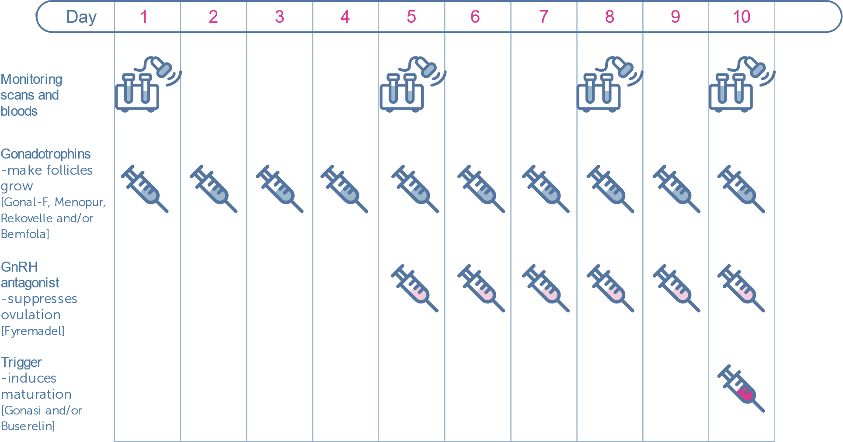

Figure 1 Short protocol for ovarian stimulation

### Poor response

Sometimes, follicles fail to respond well to the stimulating injections. Unfortunately, in these situations, there is no remedy and you may be advised to abandon the cycle. Your doctor will discuss this with you at the time and further management can be discussed at a follow-up consultation with your doctor. Typically, we would advise patients who have presented with poor ovarian response to start with a higher dose of stimulation, try different medications or try a different treatment protocol.

### Ovarian hyperstimulation syndrome (OHSS)

OHSS is possibly the most important complication of IVF treatment: the response of your ovaries to stimulation may be excessive and result in the ovaries becoming enlarged and fluid accumulating in the abdominal cavity. OHSS can occur when there are an excessive number of follicles (>20) or very high levels of the hormone oestradiol. OHSS can be characterised by varying degrees of severity:

* **Mild** OHSS can present with symptoms of abdominal swelling and discomfort, nausea, vomiting and diarrhoea. Ultrasound scans will show ovarian enlargement of less than 5 cm. Mild OHSS is monitored using ultrasound scans and can be treated with increased oral fluids and mild painkillers, such as Paracetemol.
* **Moderate** OHSS can present with symptoms similar to mild OHSS with increased severity. Ultrasound scans will show ovarian enlargement between 5 and 12 cm, and fluid accumulation in the abdominal cavity. Moderate OHSS is closely monitored using ultrasound scans and blood tests. Treatment is as per mild OHSS plus administration of intravenous fluids if necessary.
* **Severe** OHSS can present with symptoms similar to moderate OHSS as well as difficulty in breathing. Ultrasound scans will show ovarian enlargement of more than 12 cm. Luckily, severe OHSS is rare an only occurs in less than 0.5% of patients. Severe OHSS may require hospital admission. Drainage of fluid in the abdomen will relieve some of the symptoms and quickly help patients recover.

# Egg collection

The egg collection procedure is routinely performed as a day-case operation under mild intra-venous sedation (also referred to as conscious sedation) to minimise any pain or discomfort. You should not eat or drink from midnight the night before, unless instructed otherwise. You may shower or bathe on the morning of your procedure. You must not wear any make-up, perfume, nail varnish, jewellery or contact lenses on the day. Your partner or a friend should be present on the day to escort you home.

A nurse will admit you into your bay in our recovery ward. She will confirm your name and date of birth, and that you have not had anything to eat or drink since the night before. The nurse will also check if you have any allergies or other conditions. She will then provide you with materials to change into for the procedure. When you are ready, you will be introduced to the consultant anaesthetist who will talk to you about the sedation used for the egg collection.

Subsequently, you will be admitted into theatre, where you will be introduced to the embryologist. The embryologist will ask you to state your name and date of birth as part of our witnessing procedure. They will check this against your records and confirm the culture dishes that will be used for you in the lab are correctly labelled. A small canula is placed in a vein in your arm or hand for administering the anaesthetic medications during the procedure. The anaesthetist will constantly monitor your vital signs during the procedure to ensure you are appropriately sedated and kept relaxed with minimal pain.

Figure 2 vaginal egg collection

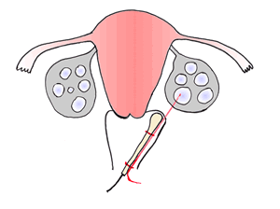

The eggs are collected using a fine needle inserted through the vagina under ultrasound guidance, as shown in Figure 1. In certain cases, if one or both ovaries are not accessible vaginally, the egg collection may be performed abdominally. The fluid from each follicle is aspirated and the fluid is passed to the embryologist who examines the it to identify an egg. If there is no egg in the fluid, the follicle is flushed with media and aspirated again. Once the follicles in one ovary have been aspirated the doctor will aspirate the follicles in the other ovary. Not all follicles will contain eggs and so the number of eggs retrieved may not correspond to the number of follicles aspirated. The egg collection procedure typically takes less than 30 minutes. Since you will have received sedation, you will be monitored for two hours after the procedure before being discharged.

**You will need to be escorted home by your partner or friend.**

**You should not drive, operate heavy machinery or sign any important documents that day. We would advise you to take full rest for the day.**

Some women will feel discomfort or soreness in the abdomen after the egg collection. Mild pain killers such as Paracetemol can be used to control this symptom and they will not interfere with your treatment. There may also be some minimal spotting, which will typically be dark brown in colour. This can be caused by the ozzing from the needle puncture site in the vagina. Some women also feel nauseous and vomit due to the anaesthetic but this should wear off quickly. If any symptoms become severe or persist please contact the clinic immediately.

# Egg freezing and storage

The eggs are prepared for vitrification by being dehydrated and placed into vitrification media. The eggs are vitrified by rapidly freezing to -196 °C in liquid nitrogen and kept in liquid nitrogen until needed. This process avoids the formation of ice crystals that damage the cellular structure within eggs. We expect more than 90% of good quality eggs to survive the freezing and thawing process when using vitrification.